Pine straw

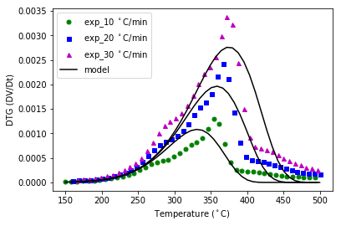

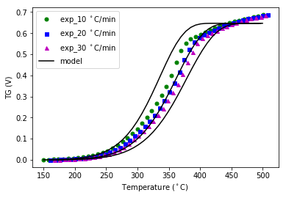

Longleaf pine live

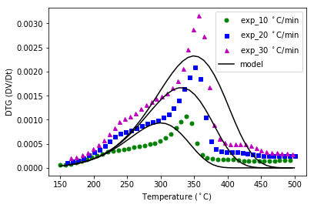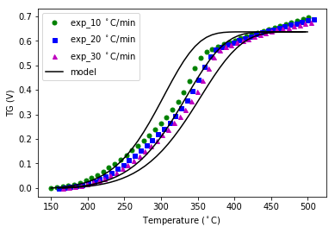

Little blue stem grass live

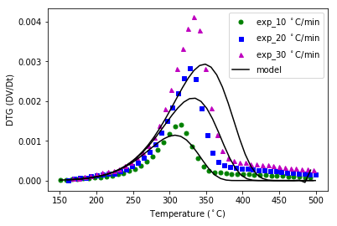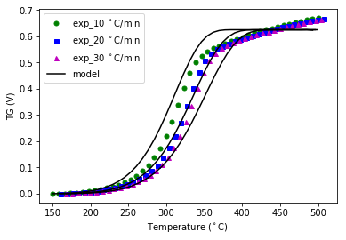

Little blue stem grass dead

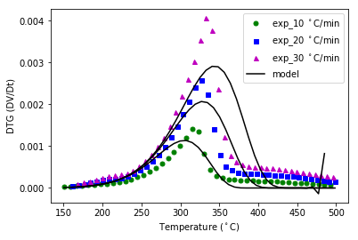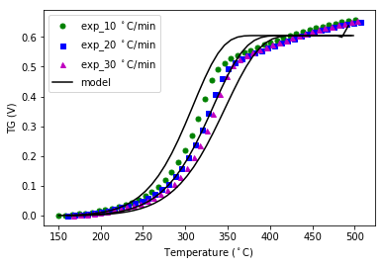

Swamp bay live

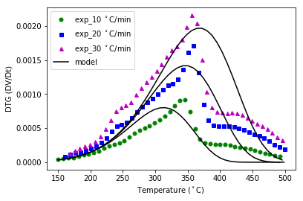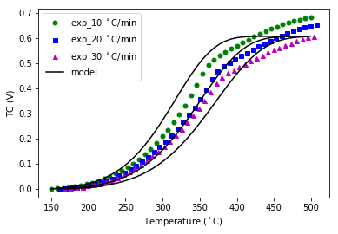

Swamp bay dead

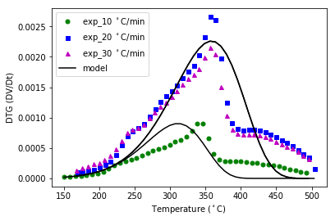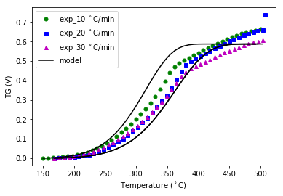

Dwarf palmetto live

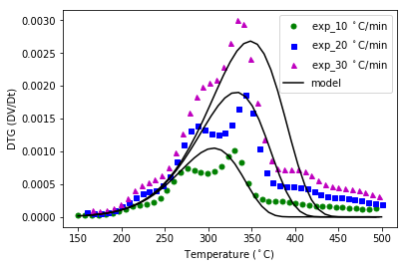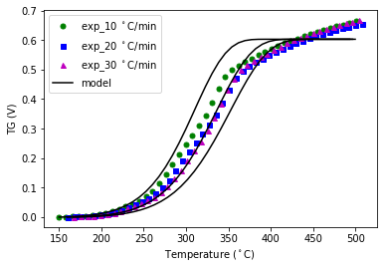

Dwarf palmetto dead

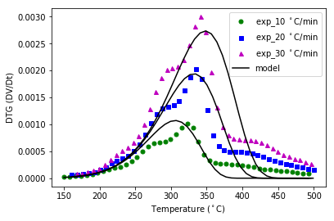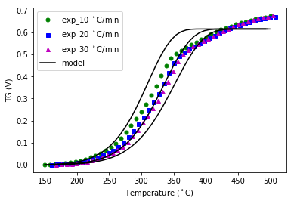

Fetterbush live

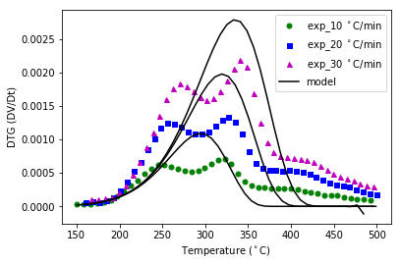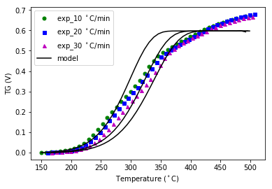

Fetterbush dead

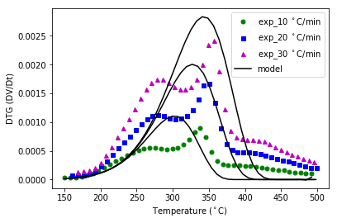

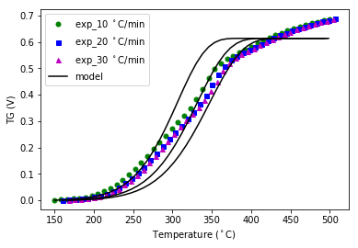

Inkberry live

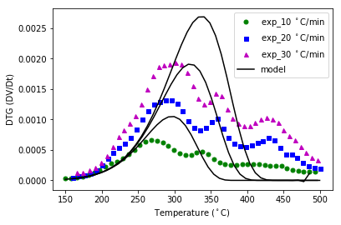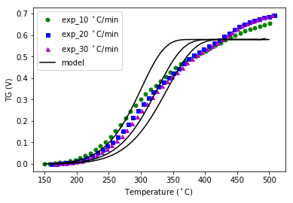

Inkberry dead

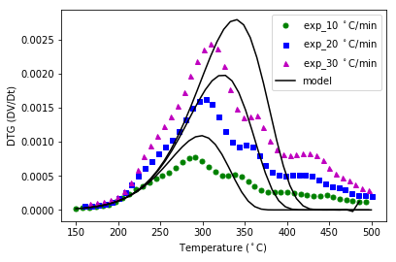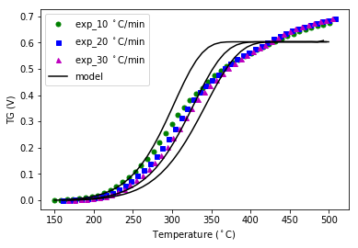

Sparkle berry live

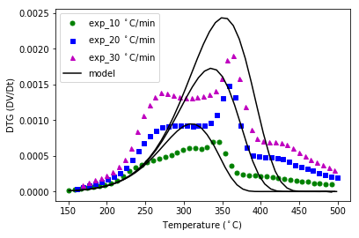

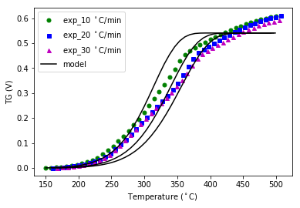

Sparkleberry dead

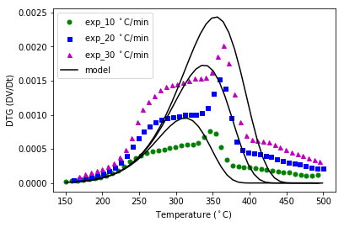

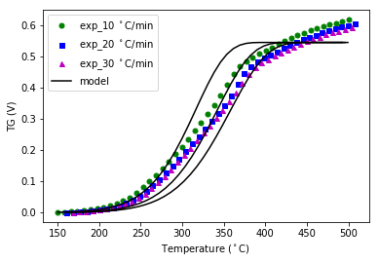

Wire grass live

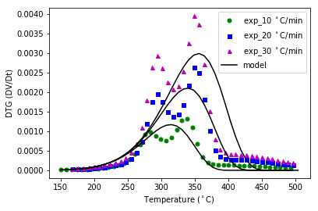

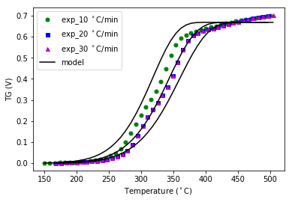

Wire grass dead

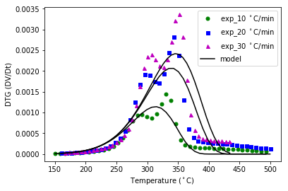

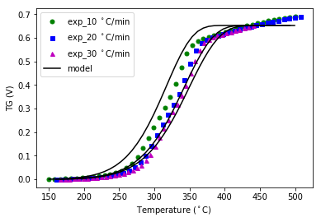

Water oak live

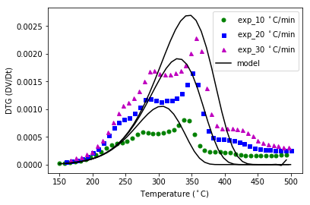

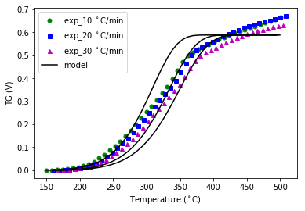

Water oak dead

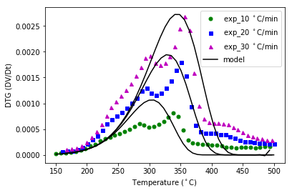

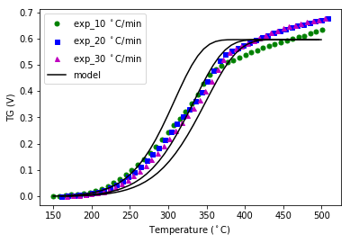

Saw palmetto live

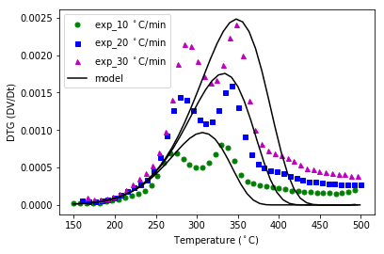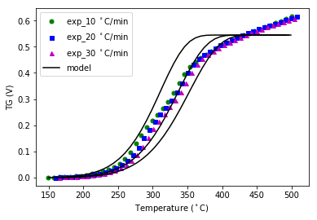

Saw palmetto dead

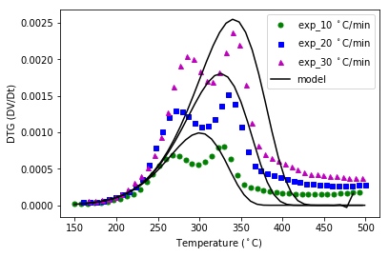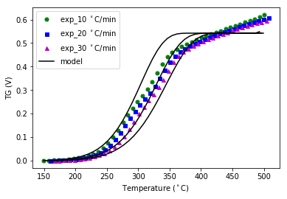

Wax live

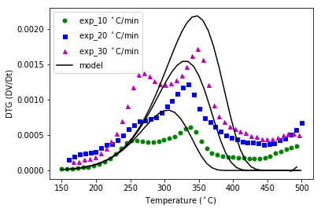

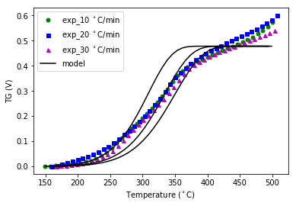

Wax dead

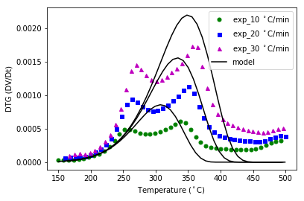

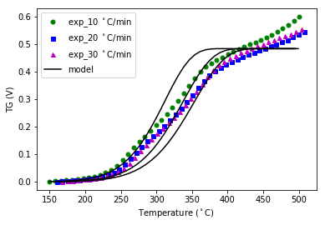

Live oak live

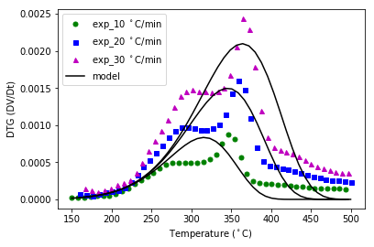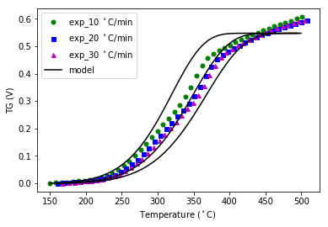

Live oak dead

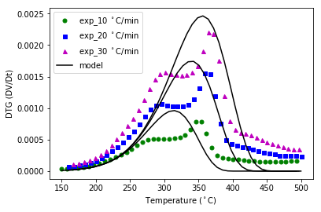

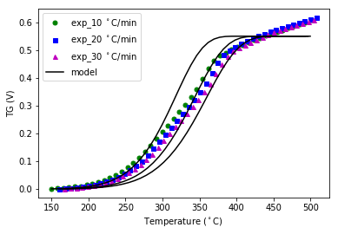

|  |  |  |  |  |  |  |
| --- | --- | --- | --- | --- | --- | --- |
|  | E | | A | | V_in | |
|  | Live | Dead | Live | Dead | Live | Dead |
| Fetterbush | 67090 | 68300 | 6162 | 6500 | .59686 | .61401 |
| Inkberry | 67146 | 67262 | 5947 | 5820 | .57930 | .60279 |
| Sparkleberry | 68678 | 68870 | 5668 | 5578 | .54047 | .54416 |
| Wire grass | 68963 | 69113 | 5456 | 5755 | .66847 | .65217 |
| Water oak | 68184 | 68142 | 5968 | 6054 | .58837 | .59555 |
| Saw palmetto | 68298 | 68634 | 5701 | 7423 | .54457 | .54229 |
| Wax | 67965 | 68250 | 5668 | 5550 | .47830 | .48298 |
| Live oak | 59899 | 68728 | 708.2 | 5232 | .54722 | .55083 |
| Long leaf pine | 54002 | 70159 | 275.1 | 4413 | .63612 | .64696 |
| Little blue stem grass | 70443 | 72109 | 9099 | 14138 | .62410 | .60451 |
| Swamp bay | 50600 | 59298 | 95.015 | 697.05 | .60771 | .58755 |
| Dwarf palmetto | 66700 | 66300 | 4100 | 3760 | .60283 | .61533 |